Java JDBC
JDBC stands for Java Database connectivity. It is a standard API provided by oracle for java application to connect / interact and execute query with different set of database i.e Oracle, Microsoft Access, MySQL, SQL Server etc.
JDBC is a API to connect and execute query with the database. JDBC API uses jdbc database drivers to connect with the database.
Why JDBC?
Class Test
{
public static void main(String[] args) {
int eid=1001;
String ename="Manjeet";
double salary=20000;
System.out.println(eid+"\t"+ename+"\t"+salary);
}
}
JDBC is used to store data permanently into the database.
How JDBC Work (Architecture of JDBC)

JDBC Application Layer
JDBC Database Database
Drivers

JDBC Driver Layar
Oracle
Oracle Driver
Java Application
JDBC API
SQL
SQL Driver

Access
Access Driver

JDBC Drivers
JDBC Driver is a software component that enables java application to interact with the database.

JDBC API
- java.sql.DriverManager
- java.sql.Connection
- java.sql.Statement
- java.sql.ResultSet
- java.sql.PreparedStatment
- java.sql.SQLException

Steps to :
Set JDBC Driver class-path for Notepad
- Download the driver for database
Eg: for MySQL
Mysql-connector.jar
- Set the MySQL connector jar file to the classpath:
Computer -> Advanced System Settings -> Environment Variable
Click on New button
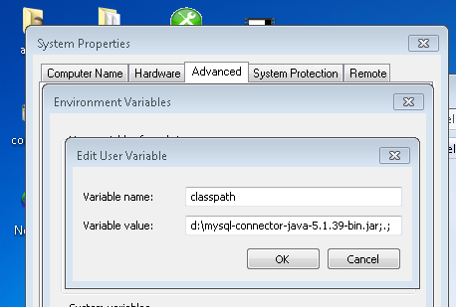

Steps to :
Set JDBC Driver for NetBeans IDE/Add jar file to the application
- Right click on Project Name i.e JavaApplication1 and select properties
- Libraries
- Click on Add Jar/Folder then a dialog box applear
- Then go to c:\program files\java\jdk\db\lib and then select
- derby and derbyclient JAR file from lib folder
- And clikc on OK button.

Five Steps to connect to the database in java
There are 5 steps to connect any java application with the database in java using JDBC. They are as follows:
- Register the driver class
- Creating connection
- Creating statement
- Executing queries
- Closing connection
1) Register the driver class
The forName() method of Class class is used to register the driver class. This method is used to dynamically load the driver class.
Syntax of forName() method
public static void forName(String className)throws ClassNotFoundException
Driver for Oracle
Class.forName("oracle.jdbc.driver.OracleDriver");
Driver for MS-ACCESS
Class.forName("sun.jdbc.odbc.JdbcOdbcDriver");
Driver for MySQL
Class.forName("com.mysql.jdbc.Driver");
Driver for derby Database
Class.forName("org.apache.derby.jdbc.ClientDriver");

2) Create the connection object
The getConnection() method of DriverManager class is used to establish connection with the database.
Syntax of getConnection() method
1) public static Connection getConnection(String url)throws SQLException
2) public static Connection getConnection(String url,String name,String password)
throws SQLException
Example to establish connection with the Oracle database
Connection conn=DriverManager.getConnection(
"jdbc:oracle:thin:@localhost:1521:xe","system","password");
Example to establish connection with the MS-ACCESS database
Connection conn=DriverManager.getConnection("jdbc:odbc:mydsn");
Example to establish connection with the MySQL database
Connection conn=DriverManager.getConnection("jdbc:mysql://localhost:3306/manjeet","root","");
Example to establish connection with the deyby database Database UserId
Connection
conn=DriverManager.getConnection("jdbc:derby://localhost:1527/bns","bns","bns");
Password
3) Create the Statement object
The createStatement() method of Connection interface is used to create statement. The object of statement is responsible to execute queries with the database.

Syntax of createStatement() method
public Statement createStatement()throws SQLException
Example to create the statement object
Statement stmt=con.createStatement();

4) Execute the query
The executeQuery(), executeUpdata() method of Statement interface is used to execute queries to the database.

executeQuery() method is used to execute SELECT query. It returns the object of ResultSet that can be used to get all the records of a table.
executeUpdate() is used to execute specified query, it may be create table, drop table, insert record, update record, delete record etc.

Syntax of executeQuery() method
public ResultSet executeQuery(String sql)throws SQLException
Example to execute query
ResultSet rs=stmt.executeQuery("select * from emp");
while(rs.next()){
System.out.println(rs.getInt(1)+" "+rs.getString(2)); }
5) Close the connection object
By closing connection object statement and ResultSet will be closed automatically. The close() method of Connection interface is used to close the connection.

Syntax of close() method
public void close()throws SQLException
Example to close connection
con.close();

Example to connect to the MySQL database
import java.sql.*;
import java.util.*;
class query{
public static void main(String args[]){
try{
Class.forName("com.mysql.jdbc.Driver"); //driver for MySQL
Connection conn=DriverManager.getConnection("jdbc:mysql://localhost:3306/manjeet","root","");
Statement stat=conn.createStatement();
ResultSet rs=stat.executeQuery("select * from stud");
while(rs.next()){
//System.out.print(rs.getInt(1));
System.out.println(rs.getInt(1)+" "+rs.getString(2));
}
conn.close(); }//try close
catch(Exception e){
System.out.println(e);}
}}
DriverManager class:
The DriverManager class acts as an interface between user and drivers. It keeps track of the drivers that are available and handles establishing a connection between a database and the appropriate driver. The DriverManager class maintains a list of Driver classes that have registered themselves by calling the method DriverManager.registerDriver().
Commonly used methods of DriverManager class:
- public static Connection getConnection(String url):- is used to establish the connection with the specified url.
- public static Connection getConnection(String url,String userName,String password):- userName,String password): is used to establish the connection with the specified url, username and password.

Connection interface:
A Connection is the session between java application and database. The Connection interface is a factory of Statement, PreparedStatement. The Connection interface provide many methods for transaction management like commit(),rollback() etc.
- public Statement createStatement(): creates a statement object that can be used to execute SQL queries.
- public Statement createStatement(int resultSetType,int resultSetConcurrency): Creates a Statement object that will generate ResultSet objects with the given type and concurrency.
- public void commit(): saves the changes made since the previous commit/rollback permanent.
- public void rollback(): Drops all changes made since the previous commit/rollback.
- public void close(): closes the connection and Releases a JDBC resources immediately.

Statement interface
The Statement interface provides methods to execute queries with the database. The statement interface is a factory of ResultSet i.e. it provides factory method to get the object of ResultSet.
Commonly used methods of Statement interface:

- public ResultSet executeQuery(String sql): is used to execute SELECT query. It returns the object of ResultSet.
- public int executeUpdate(String sql): is used to execute specified query, it may be create, drop, insert, update, delete etc.
- public boolean execute(String sql): is used to execute queries that may return multiple results.
Example
import java.sql.*;
import java.util.*;
class query{
public static void main(String args[]){
try{
Class.forName("com.mysql.jdbc.Driver"); //driver for MySQL
Connection conn=DriverManager.getConnection("jdbc:mysql://localhost:3306/manjeet","root","");
Statement stat=conn.createStatement();
int x=stat.executeUpdate("delete from stud where rno="+args[0]+"");
if(x>0)
System.out.println(“Record deleted successfully.”);
}//try close
catch(Exception e){
System.out.println(e);}}}
ResultSet interface
The object of ResultSet maintains a cursor pointing to a row of a table. Initially, cursor points to before the first row.
By default, ResultSet object can be moved forward only and it is not updatable.
But we can make this object to move forward and backward direction.
Statement stmt = con.createStatement(ResultSet.TYPE_SCROLL_INSENSITIVE,
ResultSet.CONCUR_UPDATABLE);
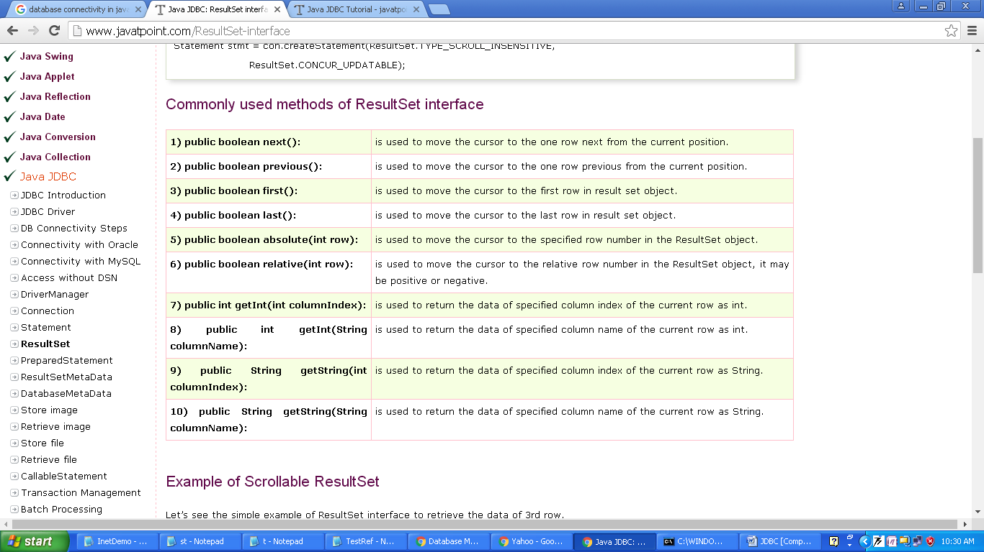
Commonly used methods of ResultSet interface

import java.sql.*;
class FetchRecord{
public static void main(String args[])throws Exception{

Class.forName("com.mysql.jdbc.Driver"); //driver for MySQL
Connection conn=DriverManager.getConnection("jdbc:mysql://localhost:3306/manjeet","root","");
Statement stmt = con.createStatement(ResultSet.TYPE_SCROLL_INSENSITIVE,
ResultSet.CONCUR_UPDATABLE);
ResultSet rs=stmt.executeQuery("select * from stud");

//getting the record of 3rd row
rs.absolute(3);
System.out.println(rs.getInt(1)+" "+rs.getString(2));

conn.close();
}}
PreparedStatement interface
The PreparedStatement interface is a subinterface of Statement. It is used to execute parameterized query. The performance of the application will be faster if you use PreparedStatement interface because query is compiled only once.
example of parameterized query
String query="insert into emp values(?,?,?)";
Note: we are passing parameter (?) for the values. Its value will be set by calling the setter methods of PreparedStatement.
Methods of PreparedStatement interface
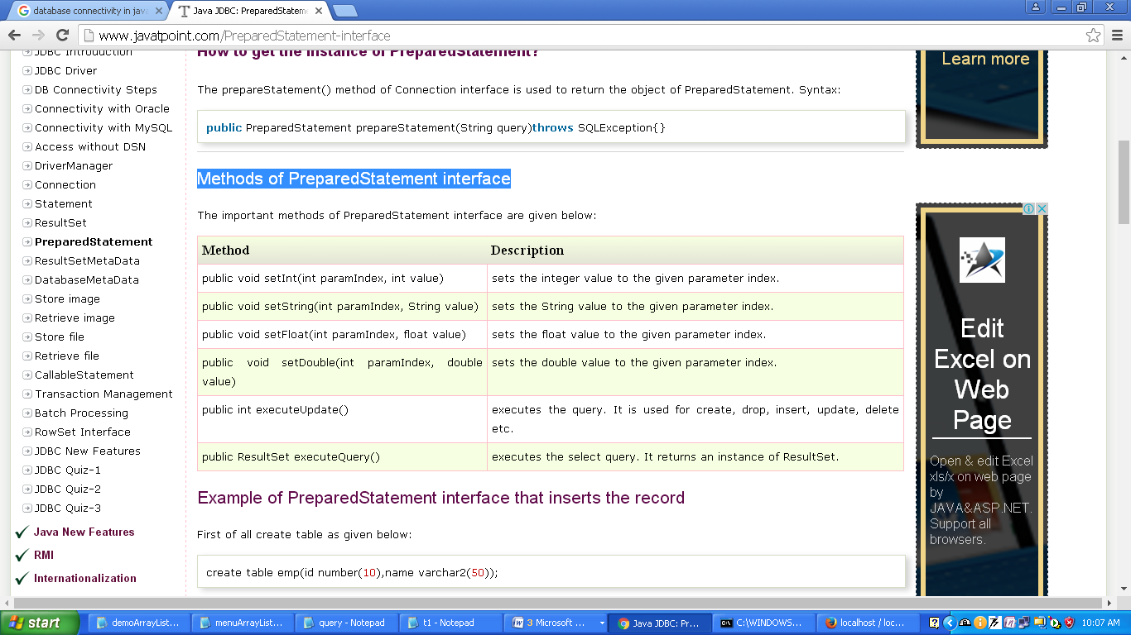

import java.sql.*;
import java.util.*;
class query{
public static void main(String args[]){
try{
Class.forName("com.mysql.jdbc.Driver"); //driver for MySQL
Connection conn=DriverManager.getConnection("jdbc:mysql://localhost:3306/manjeet","root","");
Scanner scan=new Scanner(System.in);
System.out.println("Enter the first name to be deleted:");
String n=scan.next();
PreparedStatement stat=conn.prepareStatement("delete from stud where rno=? ");
stat.setString(1,n);
int x=stat.executeUpdate();
if(x>0)
{
System.out.println("Record Deleted Successfully...");
conn.close();
stat.close();
}
else
System.out.println("Record Not found..");
}
catch(Exception e){System.out.println(e);}
}
}

